RA1911028010018

VAIBHAV SHARMA

Output:

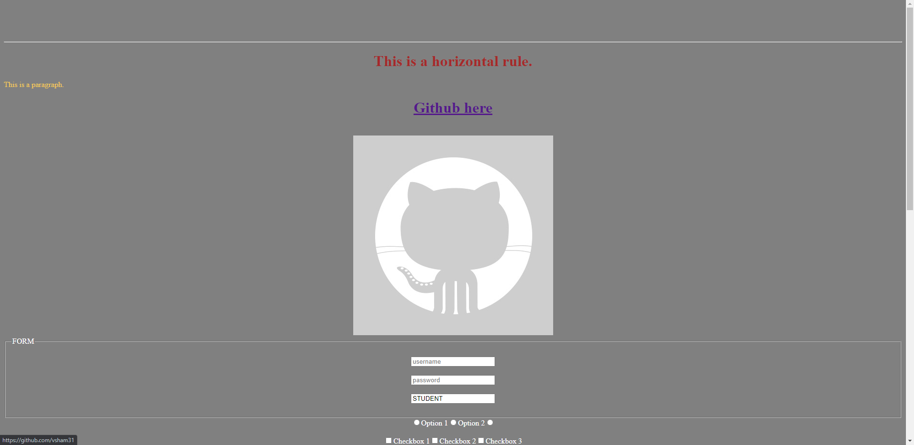

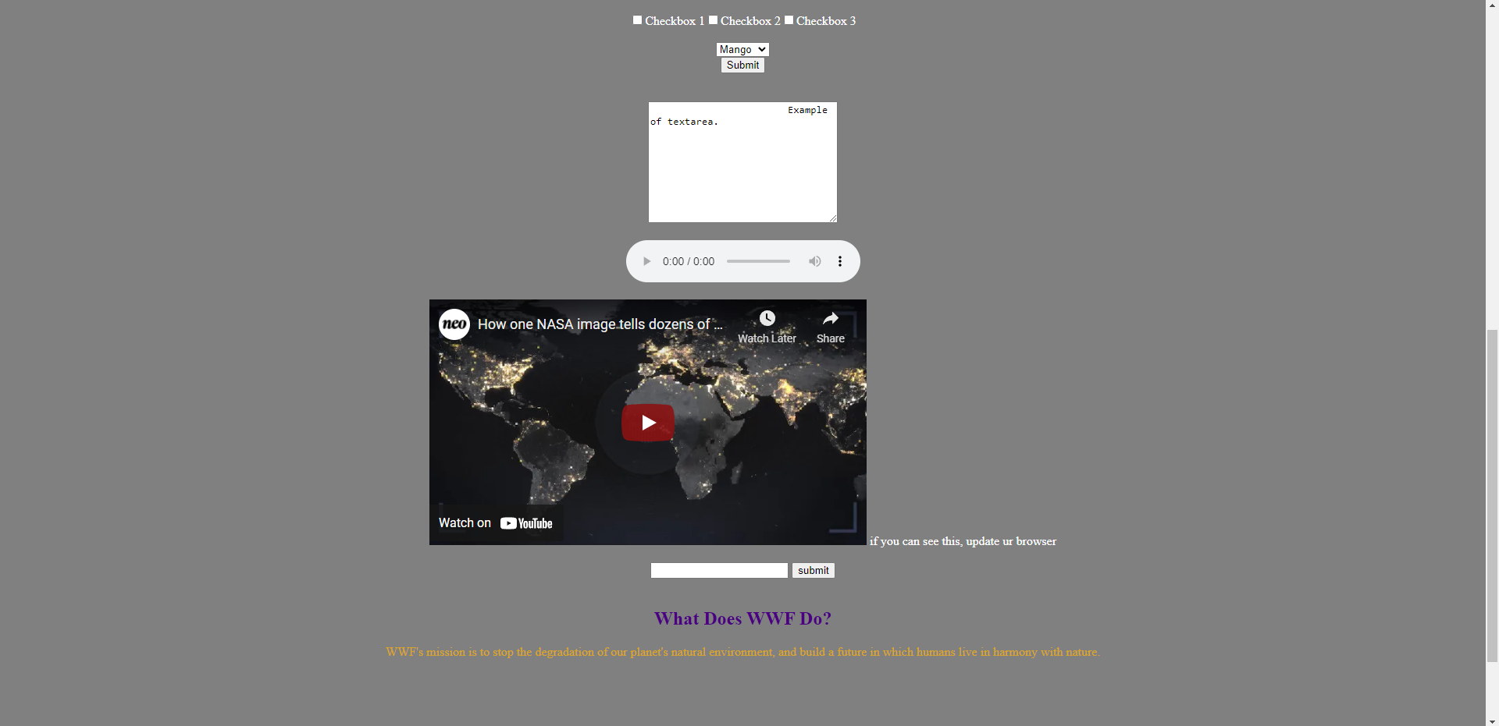

Code:

<!DOCTYPE html>

<html>

    <head>

        <meta charset="UTF-8">

        <!--<link rel="stylesheet" href="style.css">-->

        <title> html practice </title>

        <style>

        h1 {

            color:brown;

        }

        </style>

    </head>

    <body bgcolor="gray" text="white">

        <br><br><br><br>

        <hr>

        <center>

        <h1>

        This is a horizontal rule.

        </h1>

        </center>

        <p style="color:rgb(243, 201, 84);"> This is a paragraph.</p>

        <center>

        <h1><a href="https://github.com/vsham31" target="new">Github here</a></h1>

        <br>

        <a href="https://github.com/vsham31" target="new"><img src="git.jpeg"></a>

        <form autocomplete="on">

        <fieldset><legend>FORM</legend><br>

        <input type="text" placeholder="username" name="username" autocomplete="on"><br><br>

        <input type="text" placeholder="password"><br><br>

        <input type="text" value="STUDENT" readonly><br><br>

        </fieldset>

        <input type="radio">Option 1<input type="radio">Option 2<input type="radio"><br><br>

        <input type="checkbox">Checkbox 1<input type="checkbox">Checkbox 2<input type="checkbox">Checkbox 3<br><br>

        <select name="fruits">

            <option value="apple">Apple</option>

            <option value="orange">Orange</option>

            <option value="mango" selected>Mango</option>

        </select><br>

        <input type="submit"><br>

        </form>

        <br><br>

        <textarea name="message" rows="10" cols="30">

            Example of textarea.

        </textarea><br><br>

        <audio controls autoplay loop>

            <source src="music.mp3" type="audio/mpeg"/>

            if you can see this, update your browser

        </audio><br><br>

            <iframe width="560" height="315" src="https://www.youtube.com/embed/ZYGd-llxHJE" title="YouTube video player" frameborder="0" allow="accelerometer; autoplay; clipboard-write; encrypted-media; gyroscope; picture-in-picture" allowfullscreen></iframe>

            if you can see this, update ur browser

        <br><br>

            <input list="browsers" name="browser">

            <datalist id="browsers">

            <option value="Internet Explorer">

            <option value="Firefox">

            <option value="Chrome">

            <option value="Opera">

            <option value="Safari">

            </datalist>

            <input type="button" value="submit" placeholder="Datalist">

        <br><br>

        <article>

            <h1 style="color: indigo;">What Does WWF Do?</h1>

            <p style="color:goldenrod;">WWF's mission is to stop the degradation of our

            planet's natural environment, and build a future in

            which humans live in harmony with nature.</p>

        </article><br><br>

        <br><br><br><br><br><br><br><br><br><br>

        </center>

    </BoDy>

</HTML>